NTT02 – 24 Hour General Purpose Timeswitch

Product Image & Line Diagram

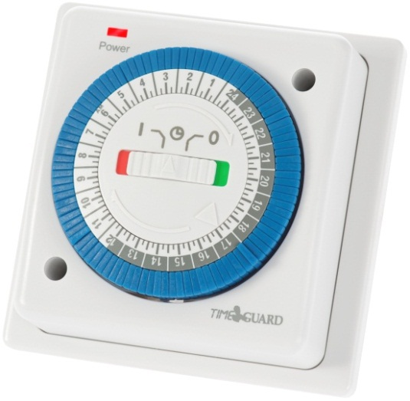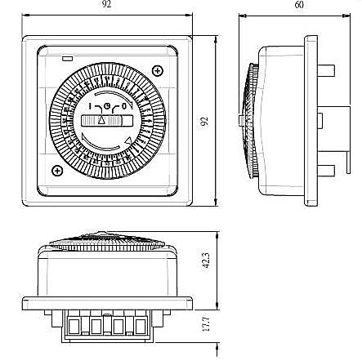

Technical Data
General
Operating Voltage | 230V AC
Frequency | 50Hz
Installation Type | Surface or recessed
Min Depth of Wall Box | 32mm, Single gang back box or pattress
Contact Type | Normally open
Class Protection | Class 2
Program | 24 Hour daily program (96 segments, 48 ON, 48 OFF)
Number of Channels | 1
Switch Rating | 16A Resistive, 8A Inductive. 1 HP. 750W Incandescent/
 | Halogen/Fluorescent, 100W CFL lighting. 100W LED Lighting.
LED Indicators | Power
Advance Function | Permanent ON/OFF or timed only
Operating Temperature | 0°C to 40°C
Accessories (Included) | Instructions, Fittings
Accessories (Optional) | None
Dimensions | Height 92mm, Width 92mm, Depth 60mm
Construction | Casing: Polycarbonate
Weight | 157g
EAN | 5012483012307
Designed In Accordance To | BS EN 60730-2-7  Includes updates and amendments.
Guarantee Period | 3 Years

