NTT04 – 24 Hour/7 Day General Purpose Timeswitch

Product Image & Line Diagram

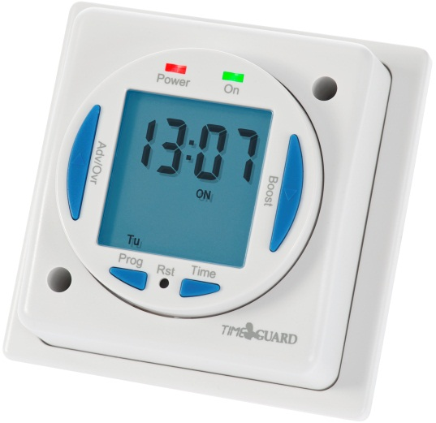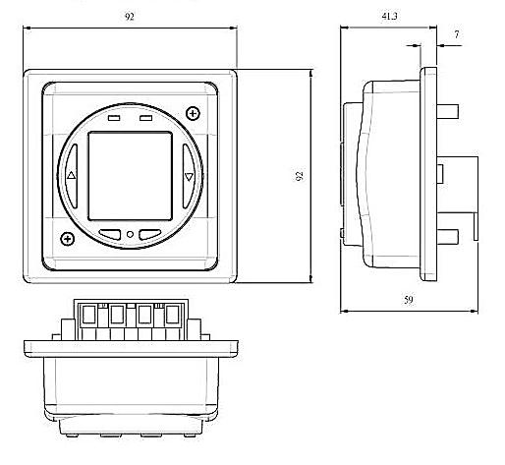

Technical Data
General
Operating Voltage | 230V AC
Frequency | 50Hz
Installation Type | Surface or recessed
Min Depth of Wall Box | 32mm, Single gang back box or pattress
Contact Type | Normally open
Class Protection | Class 2
Program | 7 Day weekly program (4 ON/OFF per day, 28 ON/OFF per week)
Number of Channels | 1
Power Reserve | Yes, 720 Hours (Non-replaceable rechargeable battery)
Switch Rating | 16A Resistive, 4A Inductive. 1 HP. 2400W Incandescent/
 | Halogen. 750W Fluorescent, 100W LED/CFL lighting.
LED Indicators | Power, Output
Boost Function | Yes, 1 Hour or 2 Hour
Advance Function | Yes, Permanent or until next programmed operation
Operating Temperature | 0°C to 40°C
Accessories (Included) | Instructions, Fittings
Accessories (Optional) | None
Dimensions | Height 92mm, Width 92mm, Depth 59mm
Construction | Casing: Polycarbonate
Weight | 168g
EAN | 5012483012321
Designed In Accordance To | BS EN 60730-2-7  Includes updates and amendments.
Guarantee Period | 3 Years

