TS900N – 24 Hour Immersion Heater Time Controller

Product Image & Line Diagram
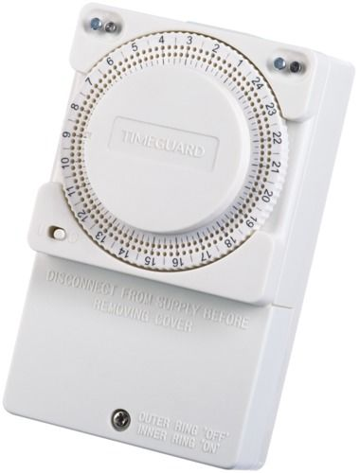

Technical Data

General
Operating Voltage | 230v AC
Frequency | 50Hz
Installation Type | Surface
Switch Rating | 13A Resistive (3kw) 400W filament, 60W fluorescent/CFL lighting. 80W LED Lighting.
Operating Temperature | 0°C to +40°C
Dimensions | Height 121.5mm, Width 74mm, Depth 41.6mm
Weight | 151g Unpacked
EAN | 5012483013380
Designed In Accordance To | BS 1363, BS EN 60730-2-7  Includes updates and amendments.
Guarantee Period | 3 Years
Functions | .
Timer Mode | 24 Hour
Programs | 24 on/off times per day, minimum on/off time between setting 30minutes
Manual Override | Self-cancelling to the next program change
Construction
Casing | Polycarbonate

