STLB1000 – 180° PIR Light Controller - Black

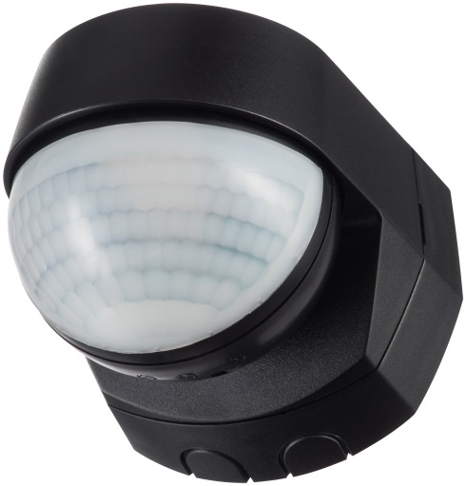
Product Image & Line Diagram

Technical Data

General
Operating Voltage | 230V AC
Frequency | 50Hz
Installation Type | Surface
Class Protection | Class 2
Number of Channels | 1
Weatherproof Rating | IP55 (Rated suitable for restricted external applications)
Operating Temperature | -20°C to + 40°C
Accessories (Included) | Instructions, Fittings, Cable clamps
Switch Rating | 1000W Incandescent/Halogen, 200W Fluorescent, 200W Low Energy/CFL, 200W LED
Accessories (Optional) | None
Dimensions | Height 76mm, Width 76mm, Depth 87mm
Weight | 119g
EAN | 5012483014301
Designed In Accordance To | BS EN 60669-2-1  Includes updates & amendments.
Guarantee Period | 2 Years
PIR Sensor
Warm Up Time | 60 Seconds
Detection Angle | 180°
Pan/Tilt Adjustment | Pan left and right 45°, Tilt down 35°
Light ON Time | 3 seconds to 18 minutes, User adjustable
Slave Terminal | Yes (Maximum of 5 STLB1000 PIR sensors can be wired in parallel. Total load must not exceed the lamp rating of a single STLB1000 unit.)
Detection Range | 8-12 meters, Fixed (Achieved at a 2.5m mounting height)
Permanent ON Facility | Yes, Pulse (6 hours max)
Dusk Until Dawn Mode | No
Lux Level | 10 - 1000, User adjustable
Construction;
PIR | Polycarbonate

