STW360 – 360° Ceiling PIR Sensor, Surface Mount

Product Image & Line Diagram
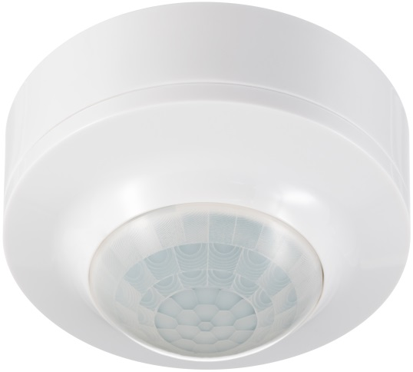

Technical Data

General
Operating Voltage | 230V AC
Frequency | 50Hz
Installation Type | Surface
Class Protection | Class 2
Number of Channels | 1
Weatherproof Rating | IP40 (Rated suitable for restricted internal applications)
Operating Temperature | -20°C to + 40°C
Accessories (Included) | Instructions, Fittings, Cable clamps
Switch Rating | 1000W Incandescent/Halogen, 200W Fluorescent, 200W Low Energy/CFL, 200W LED
Accessories (Optional) | None
Dimensions | Height 88mm, Width 88mm, Depth 50mm
Weight | 72g
EAN | 5012483014325
Designed In Accordance To | BS EN 60669-2-1  Includes updates & amendments.
Guarantee Period | 2 Years
PIR Sensor
Warm Up Time | 60 Seconds
Detection Angle | 360°
Light ON Time | 3 seconds to 18 minutes, User adjustable
Slave Terminal | Yes (Maximum of 5 STW360 PIR sensors can be wired in parallel. Total load must not exceed the lamp rating of a single STW360 unit.)
Detection Range | 6m, Fixed (Achieved at a 3m mounting height)
Permanent ON Facility | Yes, Pulse (6 hours max)
Dusk Until Dawn Mode | No
Lux Level | 10 - 1000, User adjustable
Construction;
PIR | Polycarbonate

